Yoda Bucks

You get 1 sheet every 6 weeks You can:
- Add them to a test (up to 10 points at a time)
- Use them for a hall/restroom pass
- Use as a late pass
- Use for extra points on an assignment
- Earn more for being a good citizen
- One 5 point pass = hall pass
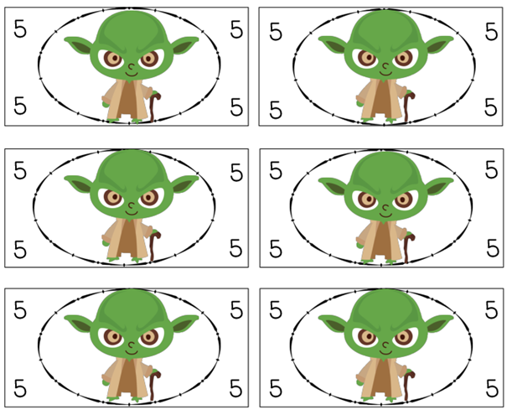

VOID

